**HW 2: Question 1**

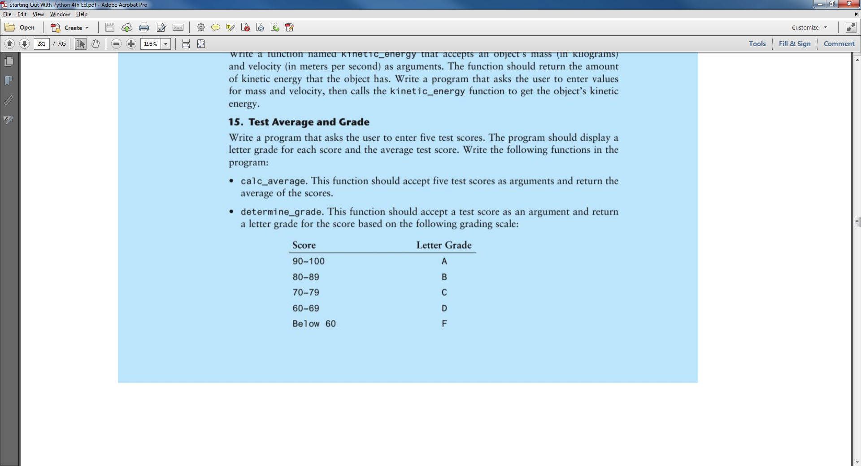

**Deliverables:**

1. Draw hierarchy chart
2. Draw IPO chart for each function
3. **Draw flowchart (can use paper & pencil and scan method)**
4. **Write python code**